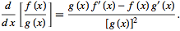
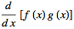
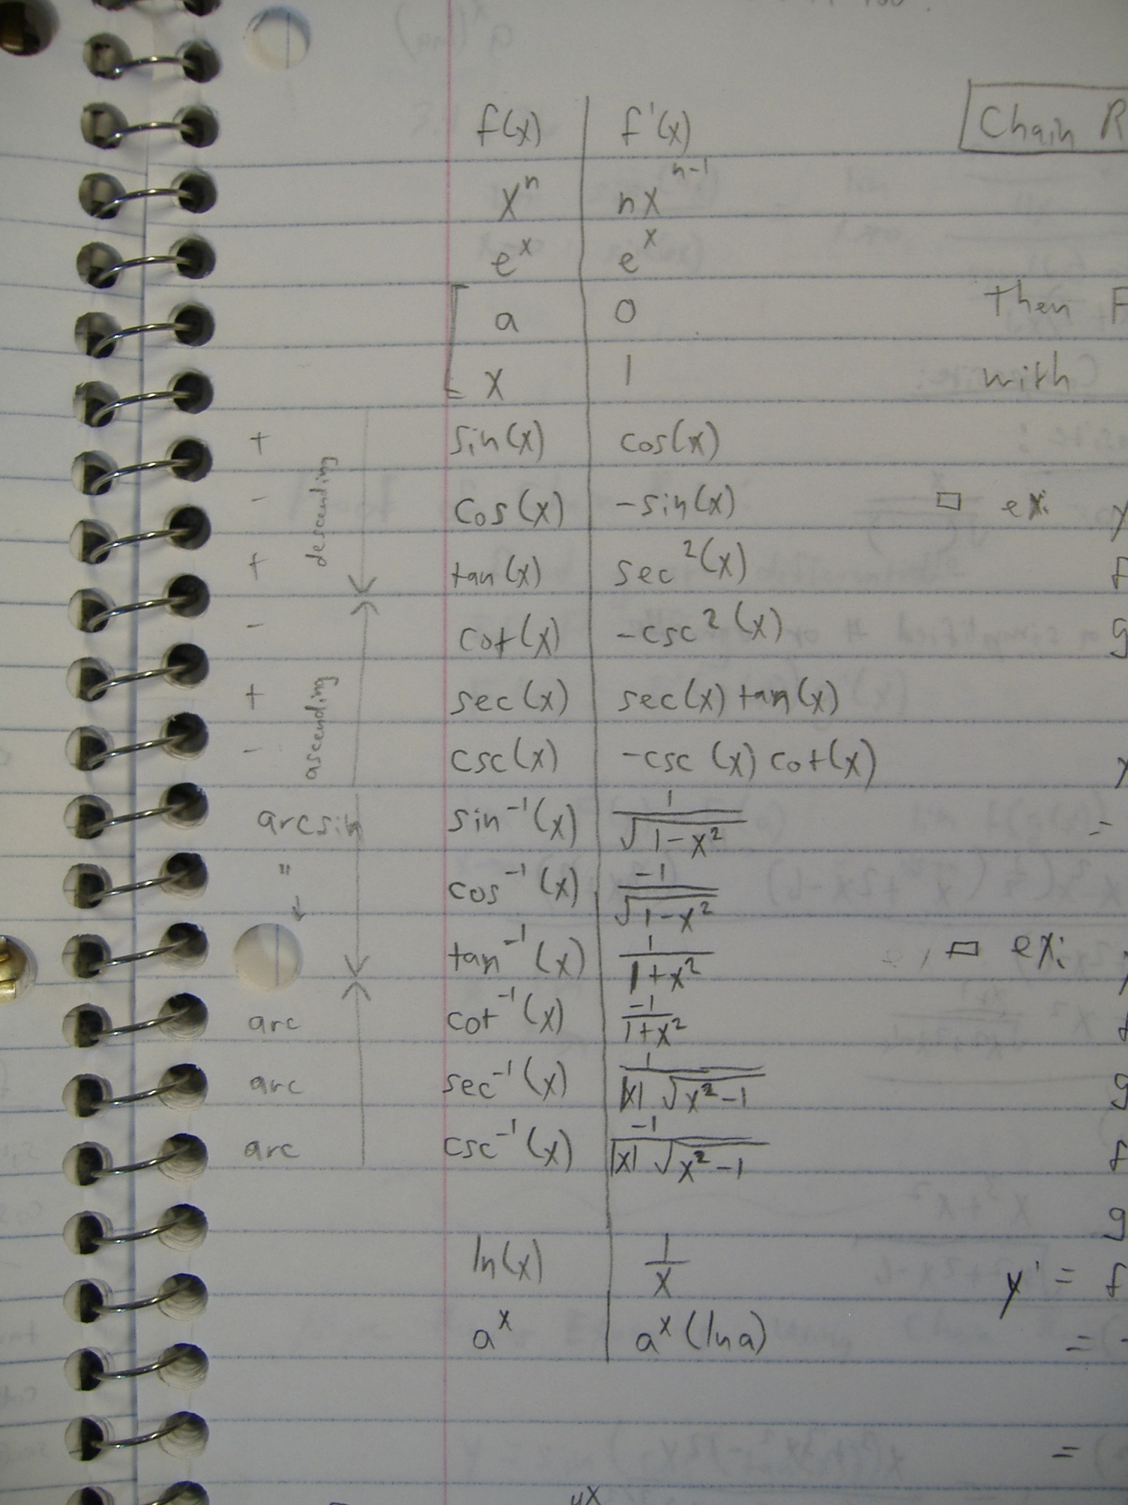
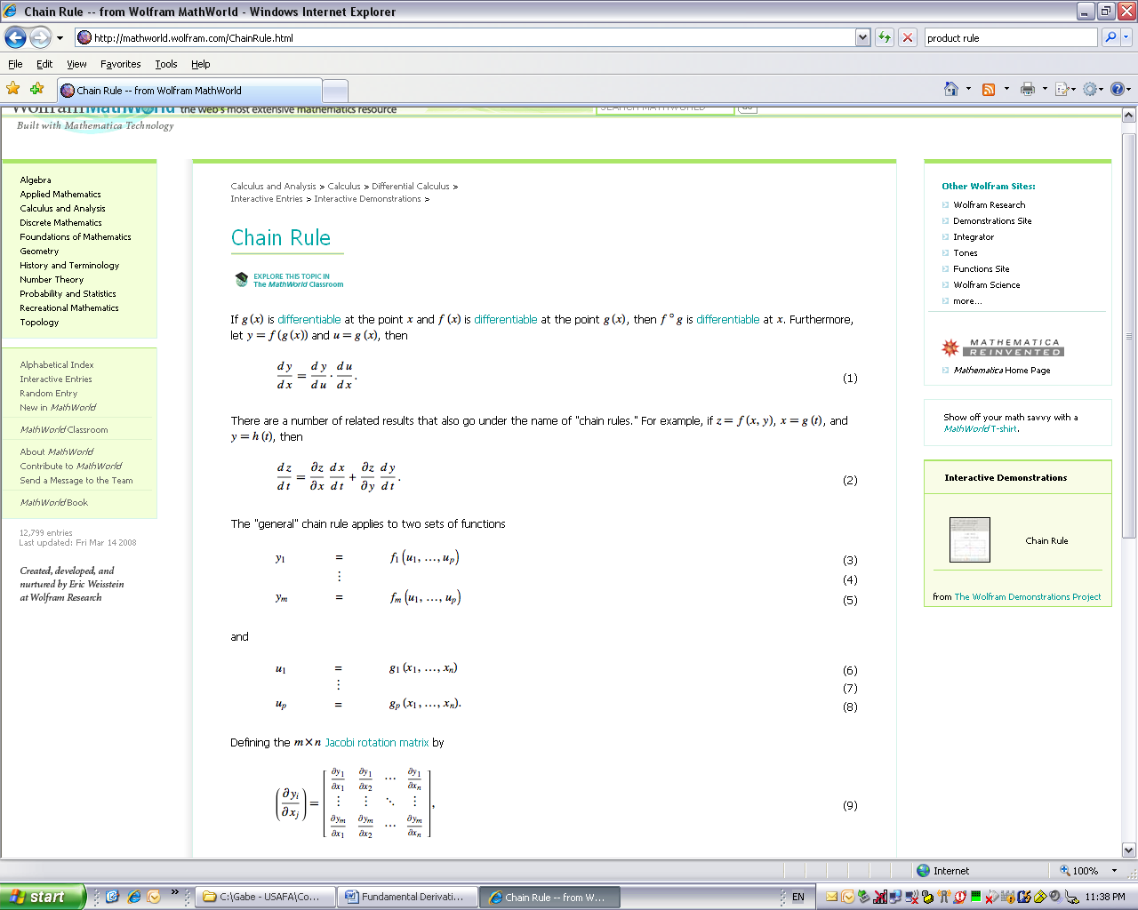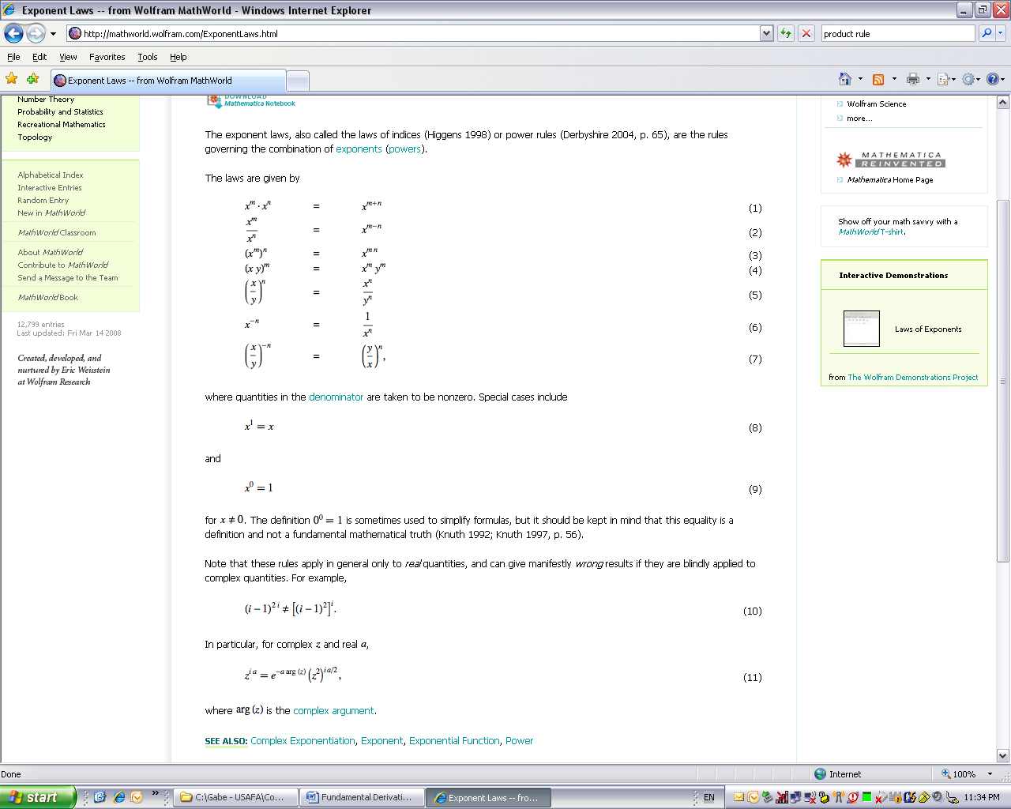
Integration by Parts:
Chain Rule:

Ex:
Equation for a Line
Point Slope Form:
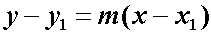

Pneumonic: “ultraviolet vudu.” Find u using “LogPoET” (choose u in this order: Logarithmic (ex: ln(x)), Polynomial (ex: 2x²+x), Exponential (ex: e^{x}), Trigonometric (ex: sin & cos)). The piece left over is dv. Differentiate u and integrate dv and then plug and chug.
Dot Product:
Ex:
Exponent Laws:

Quotient Rule:
Product Rule:
Chain Rule (“derivative of the outside times the derivative of the inside”):
$\int_{0}^{∞}{xe^{-sx}dx}$ (polynomial is higher than exponential, so choose u = x)

$u=x$ $dv= e^{-sx}dx$
$du=1dx$ $v= -\frac{1}{s}e^{-sx}$

$\int_{0}^{∞}{xe^{-sx}dx} ={\left.-\frac{1}{s}xe^{-sx}\right|}_{0}^{∞}+\frac{1}{s}\int_{0}^{∞}{e^{-sx}dx}$
$=0 \left(by L'Hopital^{'}sRule\right)-{\left.\frac{1}{s^{2}}e^{-sx}\right|}_{0}^{∞}=\frac{1}{s^{2}}$
Integration by Parts Example

